# Instructions

# Squat (Delano)

With this exercise you mainly train your hamstrings, hips, quadriceps and glutes.

1. Stand up with a straight back.
2. Put your feet at the same width as your shoulders.
3. Stretch your arms in front of you.

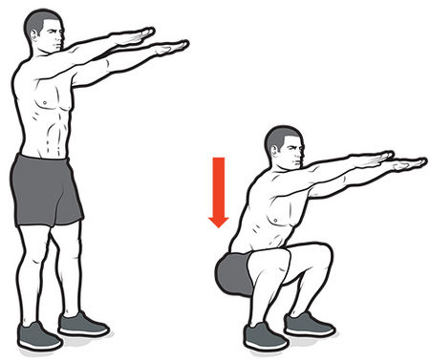

1. Go down slowly untill your legs are in a 90 degrees position.
2. Make sure that your knees won’t exceed your toes.
3. Stand back straight up.

Good luck with this good starter exercise.

# Push-up (Guido)

With this exercise you primarily train your pectoral and arm muscles.

1. Sit on your knees.
2. Put your hands close to each other on the floor, at the height of your shoulders.
3. Stretch your knees so only your toes and hands are touching the ground.

1. Lower yourself till you almost touch the ground while keeping your arms against your body.
2. Push yourself up against the floor till your arms are fully stretched out.

Good luck with this exercise.

# Dip (Guido)

WIth this exercise your primarily train your triceps.

1. For this exercise you will need 2 high walls or the right equipment.
2. Stretch your arms and leave your legs hanging in the air.

1. Hold tension on your glutes and abs.
2. Bend your arms to a 90-degree angle.
3. Push yourself up till your arms are stretched again.

Good luck with this exercise.

# Paardentrap (Guido)

1. Sit on your knees and put your hands on the floor in front of you.
2. Stretch your right leg and your left arm or the other way around.
3. Hold this position for 15 seconds.
4. Bring back your streched arm ang leg to the original position.
5. Redo this with the other arm and leg.

# Mountain climb (Guido)

1. Put your hands on the floor and strech out your legs so you are standing on your toes.
2. Pull in one of your legs so you knee is against your abs.
3. Hold this position for 15 seconds.
4. Bring back the lag to the original position.
5. Repeat this for the other leg.

# Wall sit (Guido)

With this exercise you primarily train your quadriceps, hamstrings and glutes.  
And you will also train your abs and calves a bit.

1. Search for a wall and face away from it.
2. Push yourself against the wall and take the squat position.
3. Keep tension on your thighs and keep your back straight.
4. Stay in this position till the time you set is over.

# Crunch (Guido)

With this exercise you primarily train your abs.

1. Search for a flat underground to lay on.
2. Lay on your back and put your hands on your chest.
3. Place your feet on the ground with your knees at a 90-degree angle.
4. Breathe in and lift your shoulders of the ground.
5. Curl up but keep your lower back on the ground.
6. Let your head go back down and breathe out.

# Plank (Lucas)

The plank is an exercise where you keep your body from touching the ground and only your elbow and toes touch the ground. The exercise is for improving your core strength and your belly strength.

Requirements:

* Gym clothes
* Soft mat

1. place the mat on the floor where you have enough space to lie down.

2. go down on your knees and place both hand flat on the mat surface.

3. now place your feet on the mat and then make sure that only your toes are touching the mat.

4. when this is done you only have to lie down your elbows on the mat to make sure that your back is straight like a plank.

1. And know keep this posture if you want to improve your core strength.

PS: there is no set time to hold the plank pose, you have to decide yourself if you are done.

So, know you too can perform the plank exercise in only 5 steps, it is that easy. But if you still fail to execute the exercise then we recommend watching a detailed video for more help.